Beautiful Number Patterns
Yue Kwok Choy
1. Towers
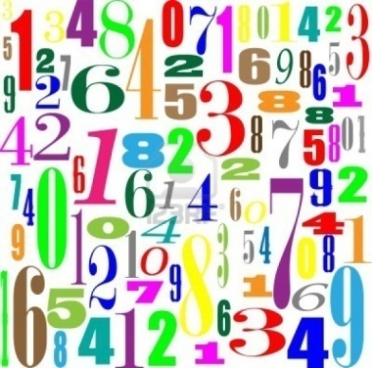
1 x 8 + 1 = 9
12 x 8 + 2 = 98
123 x 8 + 3 = 987
1234 x 8 + 4 = 9876
12345 x 8 + 5 = 98765
123456 x 8 + 6 = 987654
1234567 x 8 + 7 = 9876543
12345678 x 8 + 8 = 98765432
123456789 x 8 + 9 = 987654321

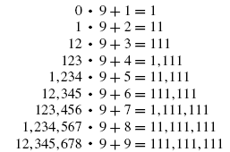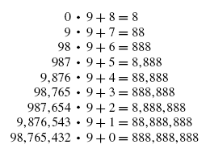

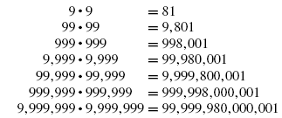
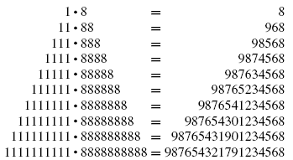

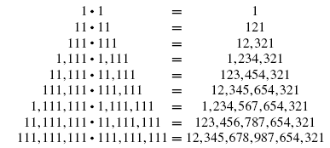
2. Product
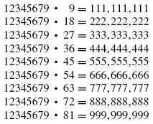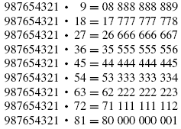

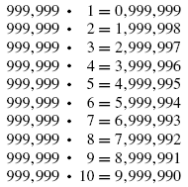

3. Need your algebra proofs
$$3^{2}+2=11$$
$${33}^{2}+22=1111$$
$${333}^{2}+222=111111$$
$${3333}^{2}+2222=11111111$$
….
1 + 2 = 3
4 + 5 + 6 = 7 + 8
9 + 10 + 11 + 12 = 13 + 14 + 15
16 + 17 + 18 + 19 + 20 = 21 + 22 + 23 + 24
….
(Can you prove it?)

$$1^{2}=1$$
$$2^{2}=1+3=1+2+1$$
$$3^{2}=1+3+5=1+2+3+2+1$$
$$4^{2}=1+3+5+7=1+2+3+4+3+2+1$$
$$5^{2}=1+3+5+7+9=1+2+3+4+5+4+3+2+1$$
$$6^{2}=1+3+5+7+9+11=1+2+3+4+5+6+5+4+3+2+1$$
….

991 × 111 = 110001
991 × 1111 = 1101001
991 × 11111 = 11011001
991 × 111111 = 110111001
991 × 1111111 = 1101111001
….
$${49}^{2}+{50}^{2}=4901$$
$${499}^{2}+{500}^{2}=499001$$
$${4999}^{2}+{5000}^{2}=49990001$$
$${49999}^{2}+{50000}^{2}=4999900001$$
….

4. Powers
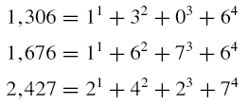
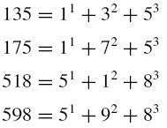
$$1676=1^{1}+6^{2}+7^{3}+6^{4}=1^{5}+6^{4}+7^{3}+6^{2}$$

$$2646798=2^{1}+6^{2}+4^{3}+6^{4}+7^{5}+9^{6}+8^{7}$$

$$444=\left(4^{1}+4^{1}+4^{1}\right)+\left(4^{2}+4^{2}+4^{2}\right)+\left(4^{3}+4^{3}+4^{3}\right)+\left(4^{4}+4^{4}+4^{4}\right)$$

$$12+56+64=24+32+76$$
$${12}^{2}+{56}^{2}+{64}^{2}={24}^{2}+{32}^{2}+76^{2}$$

$$123+561+642=242+323+761$$
$${123}^{2}+{561}^{2}+{642}^{2}={242}^{2}+{323}^{2}+7{61}^{2}$$

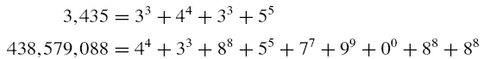

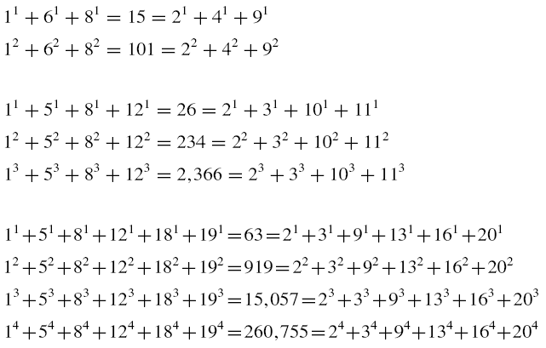

$$1237+5619+6428=2428+3237+7619$$
$${1237}^{2}+{5619}^{2}+{6428}^{2}={2428}^{2}+{3237}^{2}+7{619}^{2}$$

$$1+6+7+17+18+23=2+3+11+13+21+22$$
$$1^{2}+6^{2}+7^{2}+{11}^{2}+{18}^{2}+{23}^{2}=2^{2}+3^{2}+{11}^{2}+{13}^{2}+{21}^{2}++{22}^{2}$$
$$1^{3}+6^{3}+7^{3}+{11}^{3}+{18}^{3}+{23}^{3}=2^{3}+3^{3}+{11}^{3}+{13}^{3}+{21}^{3}++{22}^{3}$$
$$1^{4}+6^{4}+7^{4}+{11}^{4}+{18}^{4}+{23}^{4}=2^{4}+3^{4}+{11}^{4}+{13}^{4}+{21}^{4}++{22}^{4}$$
$$1^{5}+6^{5}+7^{5}+{11}^{5}+{18}^{5}+{23}^{5}=2^{5}+3^{5}+{11}^{5}+{13}^{5}+{21}^{5}++{22}^{5}$$

5. Factorials
0! × 1! = 1!
1! × 2! = 2!
6! × 7! = 10!
1! × 3! × 5! = 6!
1! × 3! × 5! × 7! = 10!
1=1!
2=2!
145=1!+4!+5!
40,585=4!+0!+5!+8!+5!

6. Cyclic
0588235294117647 x 1 = 0588235294117647
0588235294117647 x 2 = 1176470588235294
0588235294117647 x 3 = 1764705882352941
0588235294117647 x 4 = 2352941176470588
0588235294117647 x 5 = 2941176470588235
0588235294117647 x 6 = 3529411764705882
0588235294117647 x 7 = 4117647058823529
0588235294117647 x 8 = 4705882352941176
0588235294117647 x 9 = 5294117647058823
0588235294117647 x 10 = 5882352941176470
0588235294117647 x 11 = 6470588235294117
0588235294117647 x 12 = 7058823529411764
0588235294117647 x 13 = 7647058823529411
0588235294117647 x 14 = 8235294117647058
0588235294117647 x 15 = 8823529411764705
0588235294117647 x 16 = 9411764705882352

142857 × 1 ＝142857
142857 × 2＝285714
142857 × 3＝428571
142857 × 4＝571428
142857 × 5＝714285
142857 × 6＝857142

8. Prime
If A = 1, B = 2, C = 3, …, Z = 26, then PRIME =16 + 18 + 9 + 13 + 5 = 61 which is prime!

Largestest prime of digits 1 to 15
7
97
997
9973
99991
999983
9999991
99999989
999999937
9999999967
99999999977
999999999989
9999999999971
99999999999973
999999999999989

Smallest prime of digits 1 to 15
2
11
101
1009
10007
100003
1000003
10000019
100000007
1000000007
10000000019
100000000003
1000000000039
10000000000037
100000000000031

Largest Palindromic Prime Tower
2
11
929
98689
99898999
999727999
99999199999
9999987899999
999999787999999
99999999299999999
9999999992999999999
Smallest Palindromic Prime Tower
2
11
101
10301
1003001
100030001
10000500001
1000008000001
100000323000001
10000000500000001
1000000008000000001

They are prime numbers
1234567891
12345678901234567891
1234567891234567891234567891
$$28116440335967 =2^{14}+8^{14}+1^{14}+1^{14}+6^{14}+4^{14}+4^{14}+0^{14}+3^{14}+3^{14}+5^{14}+9^{14}+6^{14}+7^{14}$$
Where the length of digits = 14

9. Some More
2187 + 1234 = 3421
2187 + 12345 = 14532
2187 + 123456 = 125643
2187 + 1234567 = 1236754
2187 + 12345678 = 12347865
2187 + 123456789 = 123458976

$2=\frac{13458}{6729}$ , $3=\frac{17469}{5823}$ , $4=\frac{15768}{3942}$
$5=\frac{13458}{2697}$ , $6=\frac{17658}{2943}$ , $7=\frac{16758}{2394}$ , $8=\frac{25496}{3187}$
$9=\frac{57429}{6381}=\frac{97524}{10836}=\frac{98523}{10647}=\frac{95742}{10638}=\frac{75294}{8361}=\frac{58239}{6471}$

10. Internet search and learn more for interest
Proper divisors
Perfect numbers
Friendly numbers
Amicable numbers
Prime numbers
Twin prime numbers
Mersenne prime numbers
Factorial prime numbers
Largest prime number known

Interesting numbers and constants
Pi, π
Phi, φ, Golden Ratio
e
Square root of 2, $\sqrt{2}$
Complex number, i
Fibonacci numbers
Hardy–Ramanujan number
Taxicab number
Kaprekar's constant and “black holes” of numbers

Large numbers
Billion, Trillion
Googol
Googolplex
Skewes' number
Moser's number
Graham's number

